1. Introduction

The use of open-source software for numerical simulations has grown significantly over the past years in industrial environments. A number of studies have used open-source software for industrial practices: Janke et al. (2020) used OpenFOAM and ParMooN to simulate the turbulent air flow inside and around a naturally ventilated barn, Islas et al. (2022) simulated a computational model to protect against dust explosions in industrial facilities, He et al. (2024) adopted a model to simulate and optimize different renewable energy systems.
Despite the increasing use of open-source software, it is essential to address the challenges that companies and professionals face when using open-source in industrial environments. The numerical simulations require advanced knowledge in multiple disciplines such as computational fluid dynamics (CFD), mathematics, physics, geometry and numerical methods. Moreover, the available manuals tend to be difficult to understand for new users which result in a significant barrier to accessibility. The numerical simulations require extended period of execution, and in software like OpenFOAM, the directory structure is divided into distinct tools for pre-processing, meshing, simulating and post-processing, which are distributed across different files. Despite OpenFOAM being free, its complexity stand in contrast to commercial solvers such as COMSOL or Ansys Fluent, with integrated interfaces even tough having a higher price.
To tackle the challenges and demonstrate the potential of the numerical simulations in industrial environments, this work is focused on a case that combines experimentation and computational modeling. In particular, in the Environmental Biotechnology Laboratory (LBE) located in Narbonne, France, a cylindrical photobioreactor has been designed and assembled to produce proteins intended for human consumption (Figure 1). This reactor is fed by a gas flow and uses as a phototrophic mediator the purple phototrophic bacteria (PPB) due to their ability to grow photoheterotrphically when illuminated with near infrared (NIR) light under anaerobic conditions, assimilating simultaneously COD and nutrients (Capson-Tojo et al., 2023). During the process, the PPB consume carbon dioxide, hydrogen and biomass, promoting their growth.
Furthermore, these bacteria have a remarkable ability: they are able to break the membranes of the biomass to extract the internal components, including the polyhydroxyalkanoates (used in the manufacture of bioplastics) and proteins. The photobioreactor operates at a temperature of 26 °C and a gas flow between 0.5 and 1.5 L min-1

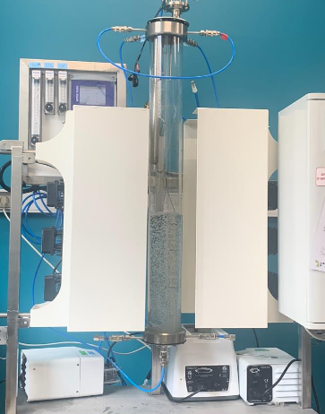

Fig 1: Photobioreactor assembled in the Environmental Biotechnology Laboratory (LBE) to produce proteins intended for human consumption.

After the experimental work, a mathematical model has been created to serve as a baseline for the numerical simulation using OpenFOAM, to improve knowledge and optimize the photobioreactor conditions. This open-source software is widely used for modeling in fluid dynamics, physical phenomena and industrial processes (BUSCAR REF).
The necessary steps to simulate the system described above, are shown in Figure 2. The process starts with the simulation of a gas-liquid flow through a volume-of-fluid (VOF) method implemented in OpenFOAM, known as interFoam. This solver permits the simulation of the transport of one immiscible phase into another under isothermal and incompressible conditions (Greenshields, 2020).
In the literature, the VOF method is known for obtaining sharp interfaces, meaning that the interface between two phases is represented as a well defined-boundary , with no width or structure (Qin and Bhadeshia, 2010). This clear delineation between phases results in the discontinuity in properties at the interface; for example, the density of air in gas phase is 1.2 kg/m3, while in the liquid phase is equal to 870 kg/m3. These disparate properties in different phases cause scalars to be effectively confined to one of the phases, leading to possible numerical leakage at the interface and negative values of the scalar concentration field (Jain and Mani, 2023).
Using interFoam as a solver, the appearance of the interface is modeled through continuous fields that gradually transition between phases instead of representing a clear boundary. This indicates the generation of a diffuse interface (Fig RB), where the properties are transported smoothly between the phases. According to Larsen et al. (2019), the appearance of the diffusive interface is due to the discretization of the transport equations, the interface compression term, and the influence of spatial and temporal resolution.
As a result of the interFoam solver, we obtain the velocity distribution, the spatial distibution of water and gas, the interface between both phases, and the pressure. This data will serve as input for the biological model, which in our case is the extended Photo-Anaerobic Model (ePAnM) - two scalar with diffuse interface. This model builds upon the Photo-Anaerobic Model (PanM) developed by Puyol et al. (2017), which considers wastewater treatment and nutrient recovery by PPB. However, this model considers PPB as a single biomass, including their fermentative and phototrophic capabilities while assuming constant environmental conditions (temperature and artificial illumination). In contrast, ePAnM incorporates many other biomass components, processes, inhibitory factors and varying environmental factors (Capson-Tojo et al., 2023).
In this work, we have implemented a more advanced model: ePAnM-two scalar and diffuse interface. This latter, introduces transport equations that maintains the confinement of variables with their respective phases, effectively avoiding numerical leakage.
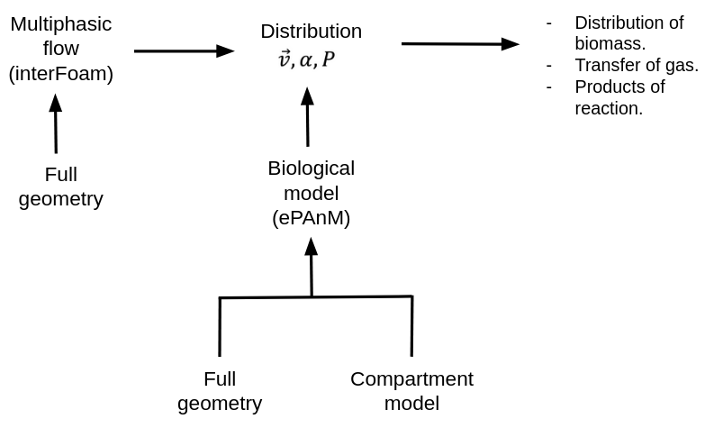
Fig 2: Photobioreactor modeling process in OpenFOAM.

Figure 3 illustrates the possible numerical representation of the photobioreactor described in Figure 1, showing the cylindrical photobioreactor in two types of meshes. The use of symmetry planes allows the computational domain to be reduced to a quarter of a cylinder (Figure 3a). This mesh contains 5 million cells, which implies the resolution of three variables (velocity, pressure and volume fraction) for each cell, using a time step of 1e-6 seconds. This leads to a week-long simulation time just to represent one second of the real process.
In contrast, Figure 3b illustrates an axisymmetric mesh that can be used as a compartment model. The latter reduces the number of cells to one hundred thousand, obtaining 50-fold reduction in the calculations and consequently, in simulation time.

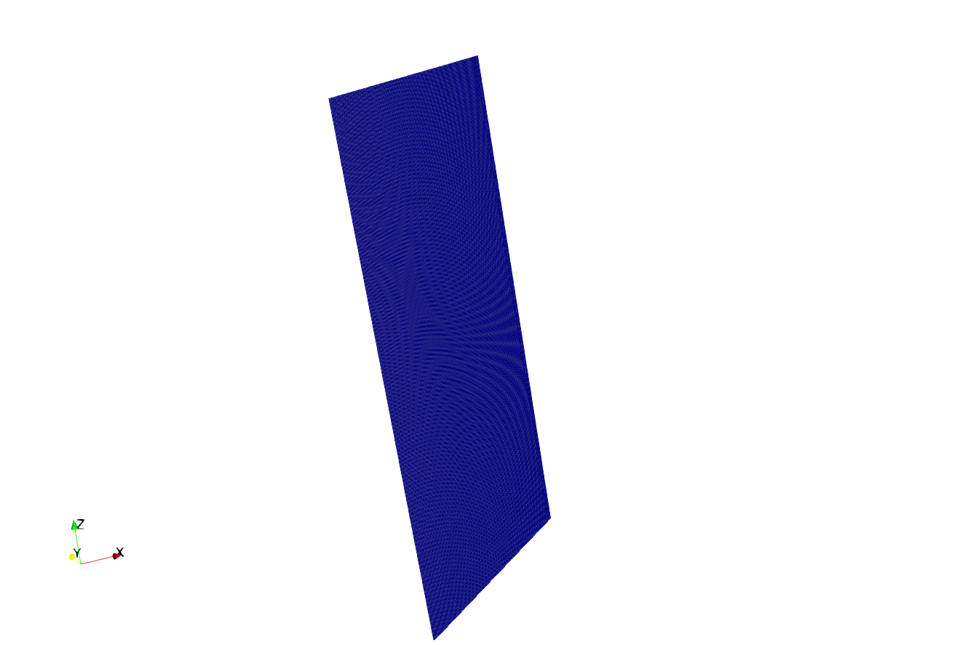
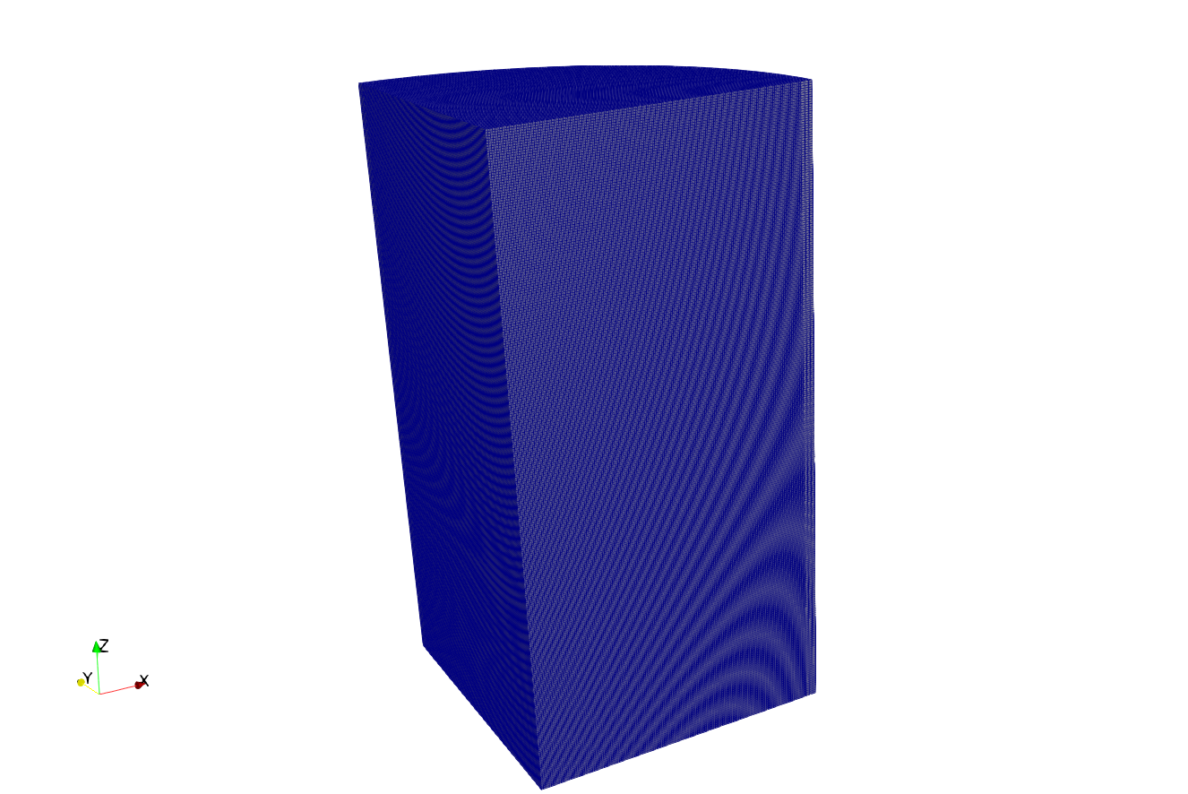

Fig 3: Meshes of the photobioractor. (a) Full geometry (b) Compartment model.

This work presents a solution to simplify the use of OpenFOAM in photobioreactor simulations, enabling its application in industrial environments in the medium term. This objective will be achieved by developing a user-friendly graphical interface that contains all the necessary tools to simulate and post-process specific geometries of the photobioreactor. The graphical user interface will allow to run simulations and analyze data intuitively, without needing to understand the underlying process. Furthermore, it will enable the execution of different geometries, including the compartment model, thus optimizing the simulation time.

Incluir:

- ePAnM-two scalar model with a diffuse interface (bioogical model) → Sin entrar mucho en detalle.
- Confinement of the variables.
- Diffuse interface, sharp interface (para nuestro modelo).
- Leakage.

Hablar de utilizar nuestro modelo implementado, y decir que a pesar de utilizar VOF (sharp gradients), tenemos diffuse interface.

REFERENCES

Janke, D., Caiazzo, A., Ahmed, N., Alia, N., Knoth, O., Moreau, B., Wilbrandt, U., Willink, D., Amon, T., John, V., 2020. On the feasibility of using open source solvers for the simulation of a turbulent air flow in a dairy barn. Computers and Electronics in Agriculture 175, 105546. https://doi.org/10.1016/j.compag.2020.105546

(Janke et al., 2020)

Islas, A., Rodríguez-Fernández, A., Betegón, C., Martínez-Pañeda, E., Pandal, A., 2022. CFD simulations of turbulent dust dispersion in the 20 L vessel using OpenFOAM. Powder Technology 397, 117033. https://doi.org/10.1016/j.powtec.2021.117033

(Islas et al., 2022)

He, Z., You, J., Kang, D., Zou, Q., Zhang, W., Zhang, Z., 2024. Overall numerical simulation of chemical-thermal-electric conversion for an all-in-one thermoelectric generator based on micro scale combustion. Energy 292, 130307. https://doi.org/10.1016/j.energy.2024.130307

(He et al., 2024)

Capson-Tojo, G., Batstone, D.J., Hülsen, T., 2023. Expanding mechanistic models to represent purple phototrophic bacteria enriched cultures growing outdoors. Water Research 229, 119401. https://doi.org/10.1016/j.watres.2022.119401

(Capson-Tojo et al., 2023)

Puyol, D., Barry, E.M., Hülsen, T., Batstone, D.J., 2017. A mechanistic model for anaerobic phototrophs in domestic wastewater applications: Photo-anaerobic model (PAnM). Water Research 116, 241–253. https://doi.org/10.1016/j.watres.2017.03.022

(Puyol et al., 2017)

Greenshields, C., 2020. OpenFOAM v8 User Guide [WWW Document]. CFD Direct. URL https://doc.cfd.direct/openfoam/user-guide-v8/index/ (accessed 3.7.25).

(Greenshields, 2020)

Qin, R., Bhadeshia, H., 2010. Phase field method. Materials Science and Technology 26, 803–811. https://doi.org/10.1179/174328409X453190

(Qin and Bhadeshia, 2010)

Jain, S.S., Mani, A., 2023. A computational model for transport of immiscible scalars in two-phase flows. Journal of Computational Physics 476, 111843. https://doi.org/10.1016/j.jcp.2022.111843

(Jain and Mani, 2023)

Burgos, E.S., Adam, E.J., 2020. Graphical user interface editor for Octave applications. Engineering Reports 2, e12269. https://doi.org/10.1002/eng2.12269

(Burgos and Adam, 2020)

Larsen, B.E., Fuhrman ,David R., and Roenby, J., 2019. Performance of interFoam on the simulation of progressive waves. Coastal Engineering Journal 61, 380–400. https://doi.org/10.1080/21664250.2019.1609713

(Larsen et al., 2019)

Companies and professionals face significant challenges when using open-source software due to its inaccessibility for new users, the complexity of manuals and tools, and long simulation time. In parallel, biological models for wastewater treatment require accurate representations of transport phenomena to improve their predictive capabilities. To enhance these models, we propose the extended Photo-Anaerobic model (ePAnM) – two scalars with a diffuse interface, which incorporates transport equations that account for both advection and diffusion, improving the representation of mass transfer in multiphase systems.
To improve computational efficiency, the model was implemented in OpenFOAM using a compartmental approach, reducing the number of cells and calculations, which significantly decreased simulation time. The compartment model was generated using various OpenFOAM utilities, and we evaluated numerical leakage and the occurrence of non-physically values in the results while also assessing the computational limitations of our system.
Finally, we developed a user-friendly graphical user interface (GUI) to simplify OpenFOAM usage. This tool allows users to execute the biological model implemented, modify its physical parameters and simulation time, and visualize results, all with a single click per action.

